# Application work flow screen shots.

**Launch Application**

While launching application provide the root directory as input argument.

**If correct operating path is provided then launch application and show options of users**

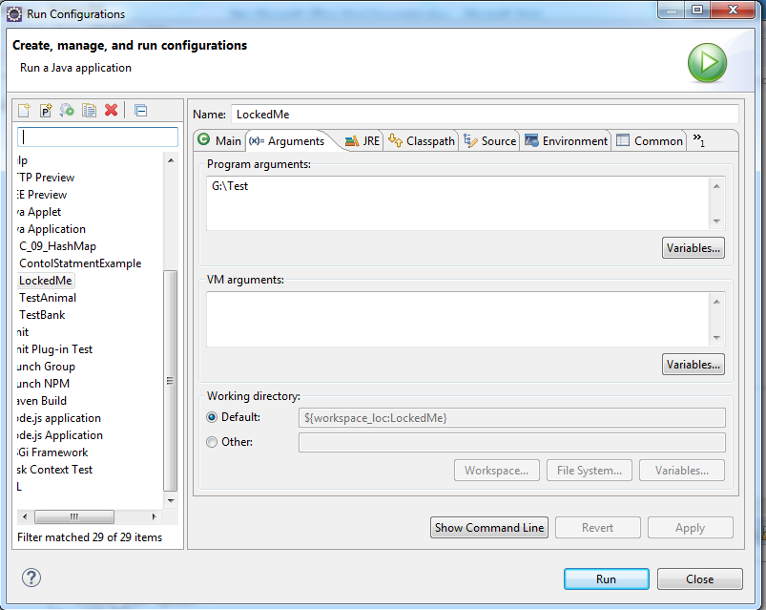

**If incorrect path is provided then application exit**

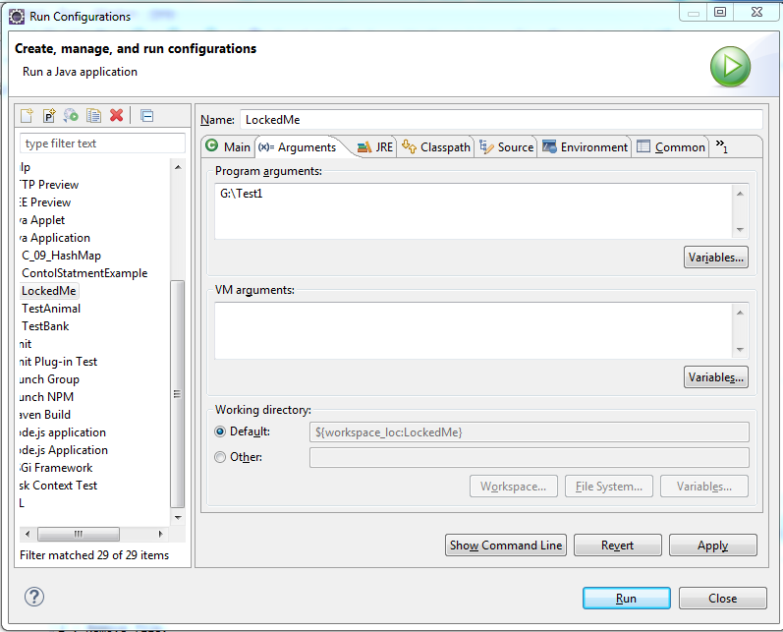

**Path G:\Test1 does not exist so application exit.**

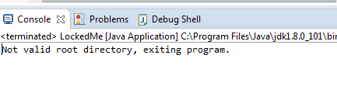

**Application Startup Screen after successful startup.**

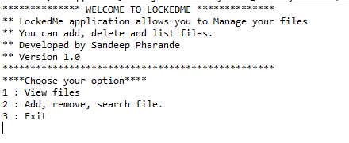

**1 View Files (This option display files in root directory in ascending order)**

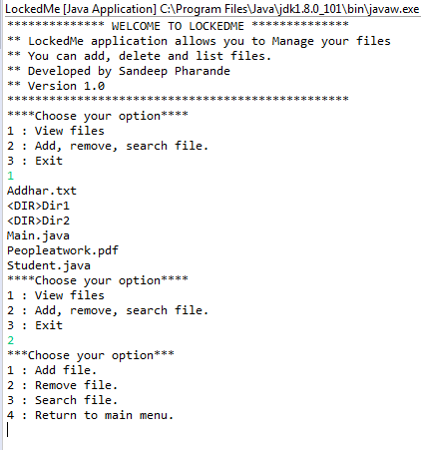

**2) Add, remove, search file. (This option allows user to add, remove or search file)**

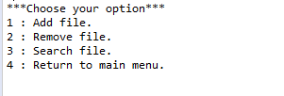

**2.1: Add file. (This option allows you to add file)**

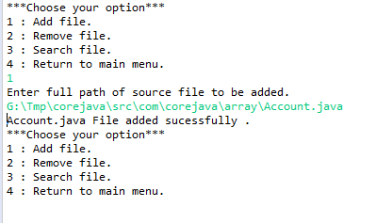

**2.2 Remove File (This option allows you to delete file from root directory)**

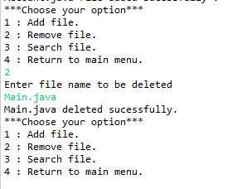

**If invalid file name provided**

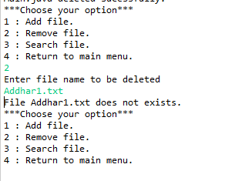

**2.3 Search file. (This option allows you to search file in the root directory)**

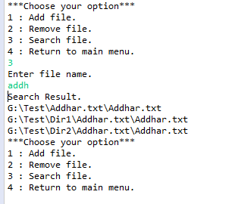

**If search criteria does not match.**

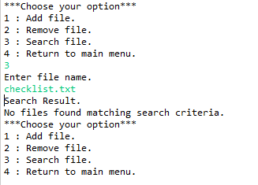

**2.4 Return to main menu**

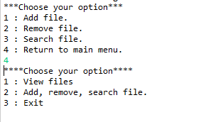

**3. Exit (Exit Application)**

